**Legislative Council**

**YOUTH JUSTICE BILL 2024**

(Amendments and New Clauses to be proposed in Committee by KATHERINE COPSEY)

1. Clause 1, page 3, lines 8 to 12, omit all words and expressions on these lines.
2. Clause 1, page 3, after line 12 insert—

"(ba) to amend the **Bail Act 1977** to provide that 2 step tests apply to children in fewer circumstances; and".

1. Chapter heading before clause 899, omit "**Trial of electronic monitoring of children on bail in certain circumstances**" and insert "**Miscellaneous Bail Act amendments**".
2. Part heading before clause 899, omit this heading.
3. Clause 899, omit this clause.
4. Clause 900, omit this clause.
5. Clause 901, omit this clause.
6. Clause 902, omit this clause.
7. Clause 903, omit this clause.
8. Clause 904, omit this clause.
9. Part heading before clause 907, omit this heading.
10. Clause 907, omit this clause.
11. Part heading before clause 908, omit this heading.

NEW CLAUSES

1. After clause 908 insert—

'Chapter 22A—Change of bail tests that apply to children

908A Definitions

In section 3 of the **Bail Act 1977** **insert** the following definition—

"***adult*** means a person who is not a child;".

908B Section 3D substituted

For section 3D of the **Bail Act 1977** **substitute**—

"3D Flow Charts

(1) A Flow Chart in this section illustrates the key features of the decision making process to which it relates. It is intended only as a guide to the reader.

(2) Flow Chart 1 shows the process for determining which tests are to be applied in deciding whether to grant bail to a person if—

(a) the person has a terrorism record; or

(b) the court considering whether to grant bail determines under section 8AA that there is a risk that the person will commit a terrorism or foreign incursion offence.

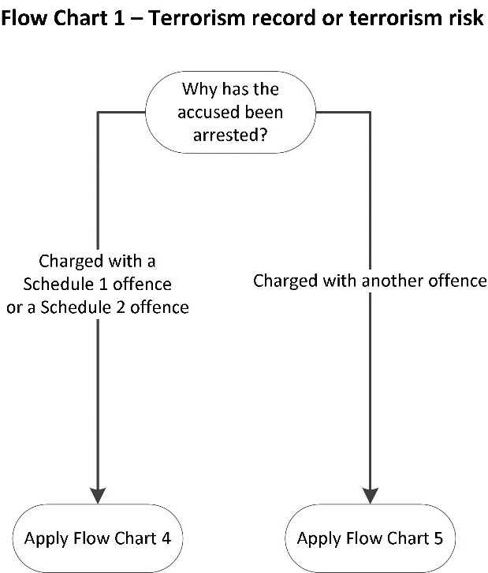

(3) Flow Chart 2 shows the process for determining which tests are to be applied in deciding whether to grant bail to an adult to whom neither subsection (2)(a) nor (b) applies.

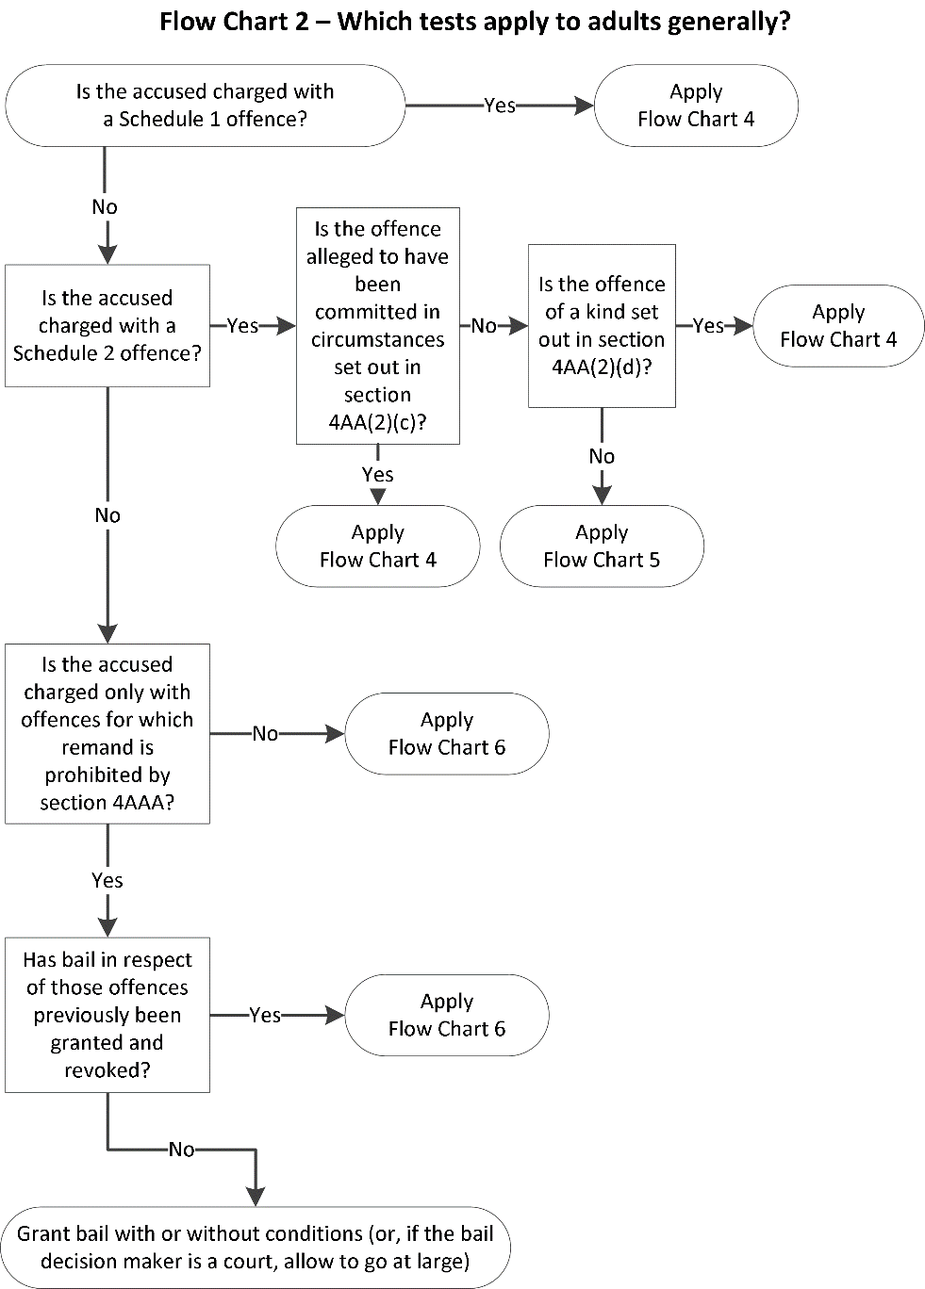

(4) Flow Chart 3 shows the process for determining which tests are to be applied in deciding whether to grant bail to a child to whom neither subsection (2)(a) nor (b) applies.

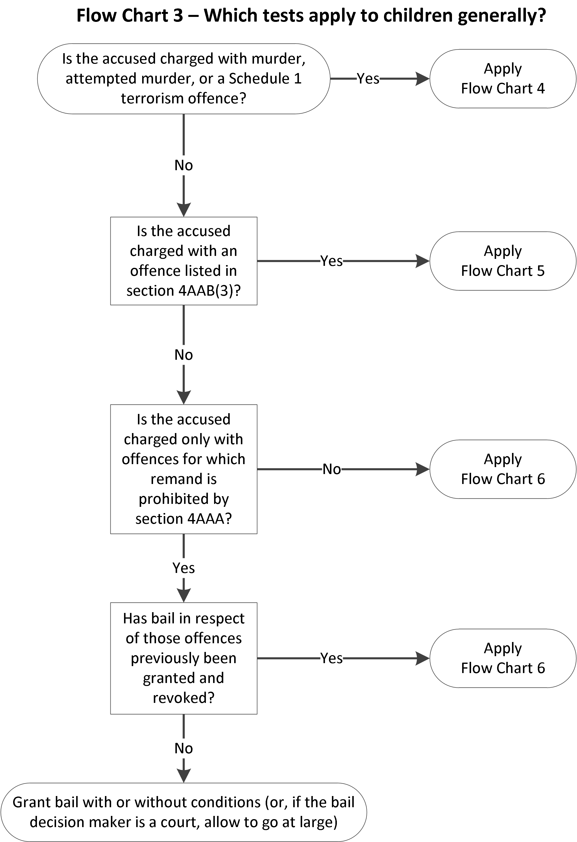

(5) Flow Chart 4 shows the process for applying the step 1—exceptional circumstances test and then the step 2—unacceptable risk test.

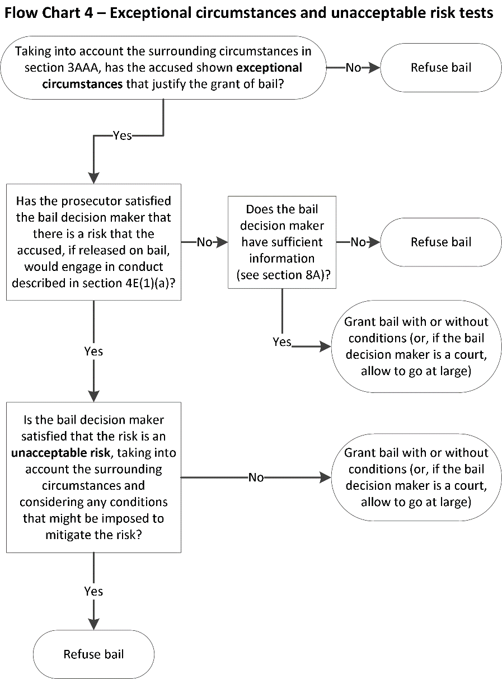

(6) Flow Chart 5 shows the process for applying the step 1—show compelling reason test and then the step 2—unacceptable risk test.

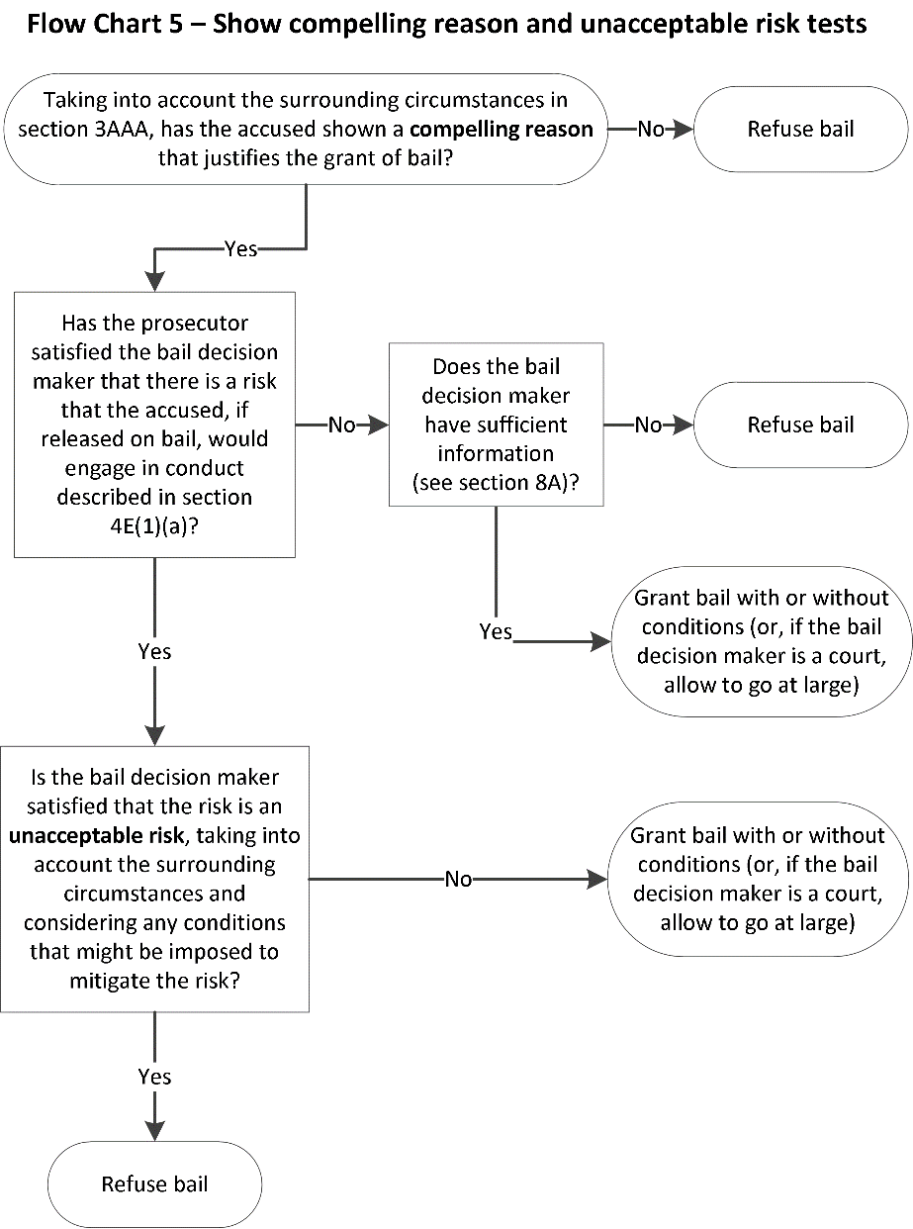

(7) Flow Chart 6 shows the process for applying the unacceptable risk test alone.

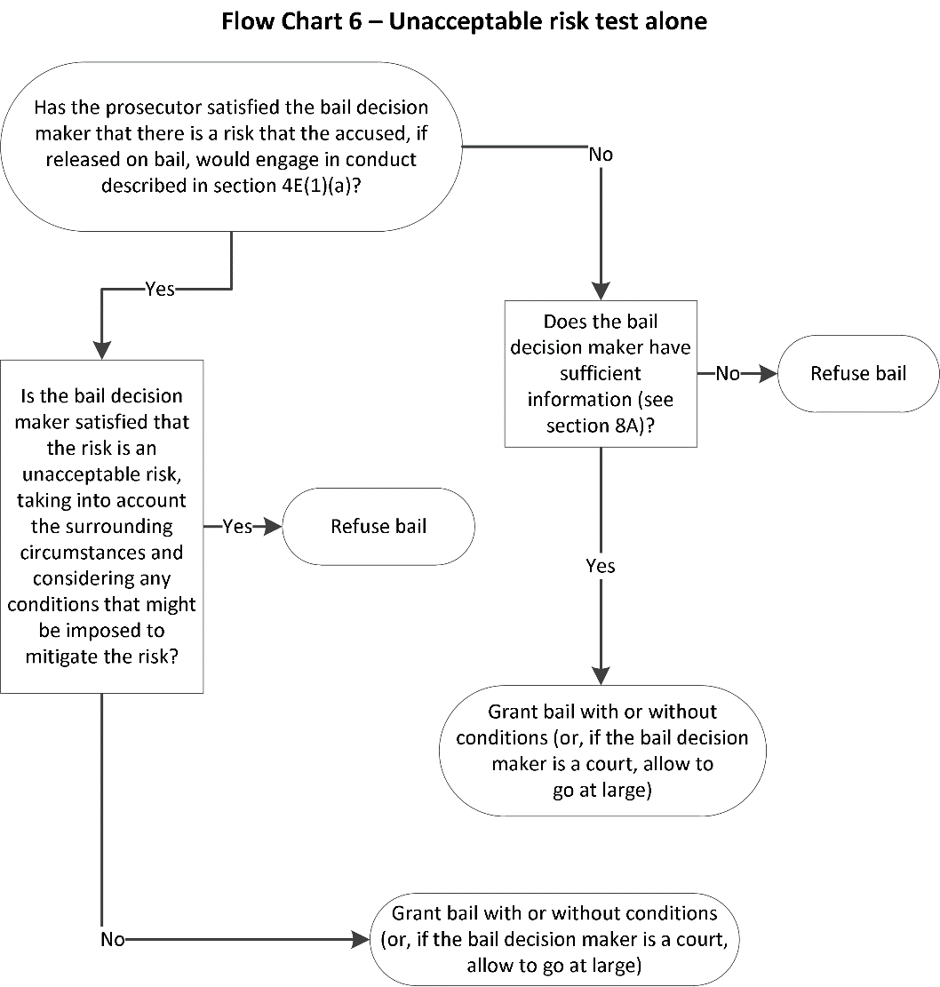

".

908C Section 4AA amended

(1) In the heading to section 4AA of the **Bail Act 1977**, after "**apply**" **insert** "**for adults**".

(2) In section 4AA(1) of the **Bail Act 1977**, for "a person accused" **substitute** "an adult who is accused".

(3) In section 4AA(2) of the **Bail Act 1977**—

(a) for "a person accused" **substitute** "an adult who is accused";

(b) in paragraphs (a) and (b), for "the person" **substitute** "the adult";

(c) in paragraph (c)(i), (ii), (iii), (iiia), (iiib), (iv), (v) and (vi), for "the accused" **substitute** "the adult".

(4) In section 4AA(3) of the **Bail Act 1977**, for "a person accused" **substitute** "an adult who is accused".

(5) In section 4AA(4) of the **Bail Act 1977**—

(a) for "a person accused" **substitute** "an adult who is accused";

(b) in paragraphs (a) and (b), for "the person" **substitute** "the adult".

(6) In section 4AA(5) of the **Bail Act 1977**, for "accused" (wherever occurring) **substitute** "adult".

908D New section 4AAB inserted

After section 4AA of the **Bail Act 1977** **insert**—

"4AAB When 2 step tests apply for children

(1) The step 1—exceptional circumstances test applies to a decision of whether to grant bail to a child who is accused of any of the following Schedule 1 offences—

(a) murder;

(b) attempted murder;

(c) an offence against section 4B(1) or 21W of the **Terrorism (Community Protection) Act 2003**.

(2) The step 1—exceptional circumstances test also applies to a decision of whether to grant bail to a child who is accused of a Schedule 1 offence not referred to in subsection (1), or a Schedule 2 offence, if—

(a) the child has a terrorism record; or

(b) the court considering whether to grant bail determines under section 8AA that there is a risk that the child will commit a terrorism or foreign incursion offence.

(3) The step 1—show compelling reason test applies to a decision of whether to grant bail to a child who is accused of any of the following Schedule 2 offences—

(a) manslaughter;

(b) child homicide;

(c) homicide by firearm;

(d) an offence against section 197A of the **Crimes Act 1958** (arson causing death);

(e) an offence against section 318(1) of the **Crimes Act 1958** (culpable driving causing death)—

unless the step 1—exceptional circumstances test applies under subsection (2).

(4) The step 1—show compelling reason test applies to a decision of whether to grant bail to a child who is accused of an offence that is neither a Schedule 1 offence nor a Schedule 2 offence if—

(a) the child has a terrorism record; or

(b) the court considering whether to grant bail determines under section 8AA that there is a risk that the child will commit a terrorism or foreign incursion offence.

**Note**

In circumstances where a step 1 test applies, section 4D provides that the unacceptable risk test will apply as a step 2 test. However, section 4D also provides that the unacceptable risk test applies even in circumstances where no step 1 test applies.".

908E Step 1—exceptional circumstances test

In section 4A(1) of the **Bail Act 1977**, for "section 4AA(1) or (2)," **substitute** "section 4AA(1) or (2) or section 4AAB(1) or (2),".

908F Step 1—show compelling reason test

In section 4C(1) of the **Bail Act 1977**, for "section 4AA(3) or (4)," **substitute** "section 4AA(3) or (4) or section 4AAB(3) or (4),".

908G When unacceptable risk test applies

In section 4D(b) of the **Bail Act 1977**, for "4AA," **substitute** "4AA or 4AAB,".

908H Court to make preliminary determination if terrorism risk alleged

(1) In section 8AA(1)(b) of the **Bail Act 1977**, for "(d);" **substitute** "(d) or section 4AAB(2)(a);".

(2) In note 2 at the foot of section 8AA(1) of the **Bail Act 1977**, for "section 4AA(1) and (2)" **substitute** "sections 4AA(1) and (2) and 4AAB(1) and (2)".

(3) In the note at the foot of section 8AA(2) of the **Bail Act 1977**, for "section 4AA(2)(b) and (4)(b)." **substitute** "sections 4AA(2)(b) and (4)(b) and 4AAB(2)(b) and (4)(b).".

**908I When bail decision maker must state reasons for granting bail**

In section 12A(1) of the **Bail Act 1977**, after "section 4AA" **insert** "or 4AAB".

908J Treason, murder, certain other offences

(1) In section 13(3)(b) of the **Bail Act 1977**, for "4AA," **substitute** "4AA or 4AAB,".

(2) In section 13(4)(a) of the **Bail Act 1977** **omit** "a child,".

908K Schedule 1 amended

For the notes below the heading to Schedule 1 to the **Bail Act 1977 substitute**—

"**Notes**

1 Section 4AA(1) sets out when an adult who is accused of an offence in this Schedule will be subject to the step 1—exceptional circumstances test.

2 Section 4AAB(1) sets out when a child who is accused of certain offences in this Schedule will be subject to the step 1—exceptional circumstances test.

3 However, the step 1—exceptional circumstances test also applies in other circumstances. See—

(a) if the accused is an adult—section 4AA(2); and

(b) if the accused is a child—section 4AAB(2).".

908L Schedule 2 amended

For the note below the heading to Schedule 2 to the **Bail Act 1977 substitute**—

"**Note**

The following provisions set out when a person who is accused of an offence in this Schedule will be subject to the step 1—exceptional circumstances test or the step 1—show compelling reason test—

(a) if the person is an adult—section 4AA(2) and (3);

(b) if the person is a child—section 4AAB(2) and (3).".

908M Transitional provisions

After section 34(23) of the **Bail Act 1977** **insert**—

"(24) An amendment made to this Act by a provision of Chapter 22A of the **Youth Justice Act 2024** applies to an application made, or an appeal commenced, under this Act on or after the commencement of that provision, regardless of when the offence is alleged to have been committed.".'.